### PROJECT REPORT ON :

o CONSUMER’S PERSECPTION

OF

V2 Vs BAAZAR KOLKATA

UNDER THE GUIDANCE OF: SUBMITTED BY:

Mr. Subhadeep Bhadra NAME: Malkit Singh ROLL NO.- 1902092 BATCH : BBA ‘B’

#### 2019-22

PREFACE

A man without practical knowledge is just like a rough diamond. To shine like a real diamond one must have practical exposure of what she has learnt. For the students of management theoretical knowledge is just like lock without key so practical knowledge is so much important.

It is quite true that world outside, your cozy home is many times quite different from what you have perceived. Similarly it is possible that theoretical knowledge acquired in the classroom may differ from the practical knowledge.

It is my pleasure to present this projrct work on the topic : CONSUMER’S PERSECPTION OF V2 Vs BAAZAR KOLKATA. This research

has expanded my horizon of knowledge in practical as well as theoretical, which is vital for students in management level studies. Such type of research promotes a student to boost his potentialities and the inner qualities. And this has indeed proved to be very useful to students.

ACKNOWLEDGEMENT

The project work is on the topic: ‘CONSUMER’S PERSECPTION OF V2 Vs BAAZAR KOLKATA’. I would rejoice to express emphatically with profound sense of gratitude and highest veneration, my sincere thanks to Pro. Subhadeep Bhadra for giving me guidance for this project.

I am short of words to express my respect and honour to my parents and family members and friends who showered their blessings, affection, encouragement and inspiration, without which this report would not have been finalize.

I also express my sincere thanks to my friends who helped me differently in the completion of my work.

Last but not least, I also thank all those people whom I met during the survey and helped me to accomplish my assignments in the most efficient and effective manner.

DECLARATION

I Makit singh hereby declare that the project report on “CONSUMER’S PERSECPTION OF V2 Vs BAAZAR KOLKATA” is a result

of my own work. Under any evitable circumstances, if my project could be scrutinized and screened which evades of copying, I am liable for any demarcation/ variation of marks whatsoever my guide of this project deems fit.

CERTIFICATE BY INTERNAL GUIDE

TABLE OF CONTENT

|  |  |
| --- | --- |
| PARTICULARS | PAGE  NO. |
|  |  |
| INTRODUCTION | 8 |
| 8.1 About V2 |  |
| 8.2 About baazar kolkata | 9 |
| Company Profile Of V2 | 10_12 |
| Company Profile Of Baazar Kolkata | 13_14 |
| Research Methodology og v2 and baazar kolkata | 15 |
| Data Analysis Of V2 vs Baazar Kolkata | 16_30 |
| Suggestions and Recommendation | 31 |
| Conclusion | 32 |
| Bibliography | 33 |
| Annexure | 34_36 |

TABLE OF GRAPH

|  |  |
| --- | --- |
| PARTICULARS | PAGE  NO. |
|  |  |
| Overview quartely revenue of V2 | 11 |
| Shareholdings of V2 | 12 |
| Consumer perception on knowing V2 and baazar  kolkata | 16 |
| Consumer perception on wide selection | 17 |
| Consumer perception on best quality of product | 18 |
| Consumer perception on respondent towards  consumer | 19 |
| Consumer perception on more yearly discount | 20 |
| Consumer perception on franchise | 21 |
| Consumer perception on salesman for service | 22 |
| Consumer perception on area of store | 23 |
| Consumer perception on advertisement of store | 24 |
| Consumer perception on more no. of brands | 25 |
| Consumer perception on online shopping | 26 |
| Consumer perception on affordable price | 27 |
| Consumer perception on safety towards consumer | 28 |
| Consumer perception on easy return policy | 29 |
| Consumer perception on feedback | 30 |

INTRODUCTION

* 1. ABOUT V2

V2 Retail offers an unparalleled retail mix combined with value and variety to its shoppers. This fashion avenue gives an extraordinary experience with an embracing portfolio of product offerings. V2 retail believes in offering complete Value for money to the shoppers through its large Variety of Smart, Trendy, Fashionable apparels across categories under one roof.

Its presence in 17 states of India with 77 high fashionable Operational stores, make us stand amongst the pioneers in setting up unique precincts with modern ambience retail chain. It dedicatedly lead the significant shopping experience to various small towns and cities like Patna, Sagar, Itanagar, Varanasi and many more.

With more than 25 years of experience, V2 Retail Limited is now India’s Fastest Growing Retail Chain Companies. Since beginning V2 Retail hasn’t look back and aimed to reach new heights every now and then. With the guidance of our Chairman – Mr. Ram Chandra Agarwal, the company has pioneered in managing 9,00,000 + sq.ft. of retail space with a firm belief in fundamentals of value and variety to billions of retail consumers. At present V2 Retail proudly owned 77 retail stores in 17 states of the country out of which 3 in Delhi-NCR, 18 in Bihar, 17 in Uttar Pradesh, 7 in Odisha, 4 in Assam, 7 in Jharkhand, 4 in Uttarakhand ,6 in Karnataka,1 in Himachal Pradesh, 1 in Arunachal Pradesh, 3 in Madhya Pradesh, 1 in Tripura, 2 in J&K, 1 each in Rajasthan,Telangana & Goa. Serving with the right ethics V2 Retail has successfully conquered the Indian Retail Market and the journey has created many firsts in the Industry. The journey till

date remained awesome for us and our shoppers and we have the strongest potential to take this long with the same enthusiasm in the future.

* 1. ABOUT BAAZAR KOLKATA

Since 2002 "Baazar Kolkata" is part of value retail format. It is one of the oldest growing value retail formats in the Eastern Region. ‘Baazar Kolkata’ is one of the pioneers in value-for-money retail in Eastern India. It is been awarded the ‘Most Successful Value Retailer in East India’ thrice by Images Retail Awards.

Currently, its operate through 90 stores, with retail space of 4 Lacs sqft located in the states of West Bengal, Uttar Pradesh, Bihar, Jharkhand, Tripura, Assam & Odisha. Many more stores are in pipeline for the year 2020

With a keen understanding of the budgetary constraints faced by the average shoppers in getting fashionable and trendy apparels at an affordable price. Price, they cater to everyone with the best buying options under one roof. They work very carefully on the following aspects.

Baazar Kolkata, one of the leading local apparel retail chains of Eastern India is on a major expansion drive across the zone. The chain has recently opened two new stores in this region, one in Baruipur, suburbs of Kolkata and the other one is in Hajaribagh in Jharkhand. With this, their total store count reaches to 40 outlets, spread across Eastern India located in states of West Bengal, Odisha, Jharkhand, Uttar Pradesh, Bihar and Tripura. They offer a widest assortment of products for lifestyle, fashion, home and entertainment at reasonable price to the customers. The Baazar Kolkata stores are primarily large stores spread across an area between 8,000-10,000 sq.ft.

On the collection launch Umesh Sharma said, “At Bazaar Kolkata, we have always kept in mind the customer’s demand by giving them quality products at a reasonable price and thus introduced widespread Durga Puja collections of clothes, household products and accessories. We give huge emphasis on all-round quality in products, stores, service standards, and customer engagement programs. We want our customers to enjoy their time while shopping at Baazar Kolkata and hope to satisfy them with our products.”

COMPANY PROFILE OF V2

## STRENGTH :

* + - Rising Net Cash Flow and Cash from Operating activity
    - Growth in Net Profit with increasing Profit Margin
    - Increasing profits every quarter for the past 2 quarters
    - Company able to generate Net Cash - Improving Net Cash Flow for last 2 years
    - Company with Zero Promoter Pledge

## WEAKNESS :

* + - Red Flag: High Interest Payments Compared to Earnings
    - MFs decreased their shareholding last quarter
    - Inefficient use of capital to generate profits - RoCE declining in the last 2 years
    - Inefficient use of shareholder funds - ROE declining in the last 2 years
    - Inefficient use of assets to generate profits - ROA declining in the last 2 years
    - Degrowth in Revenue and Profit
    - Low Piotroski Score : Companies with weak financials
    - Annual net profit declining for last 2 years

## OPPORTUNITIES :

* Highest Recovery from 52 Week Low
* Stock with Low PE (PE < = 10)
* RSI indicating price strength
* High Volume, High Gain
* Insiders bought stocks

## THREATS :

* + Companies Increasing Debt as per Annual Report

# OVERVIEW QUARTERLY REVENUE OF V2

0

Series1

400

200

Revenue

SHAREHOLDINGS :



0.01%

38.40%

53.62%

1.52%

6.45%

PROMOTER FII DII PUBLIC OTHERS

**IT’S MISSION :**

As the name itself suggests, Value and Variety, we happily make availability of the finest clothing range at a remarkably affordable price and we aim to give this experience to each shopper who wants to be trendy but unable due to the high cost of other brands.

**Ram Chandra Agarwal**

**Chairman And Managing Director**

Ram Chandra Agarwal started his retail journey in early 1994 from Kolkata, India. He has over 30 years of entrepreneurial and business acumen. Being one of the key pioneers in India, Mr. Ram introduced the concept of value retailing in 2001. Mr. Ram Chandra Agarwal has been the chairman & managing director

of v2 retail since July 2011.

COMPANY PROFILE OF BAAZAR KOLKATA

#### VISION AND MISSION

* + VISION :

To provide quality products at the most affordable price to the highest number of customers and at points closest to them

* + MISSION :

To be a quality-conscious corporate providing the best value-for-money proposition to the end users.

#### STRENGTH

* To understand the customer requirements, needs, wants.
* Providing the wide range of products within the one roof.
* Operating at the Indian major cities.
* Providing the best infrastructure facilities in every shop.
* Having home-delivery facilities.
* Providing the best quality brand products and also advertising by celebrities.
* People are attracting towards the Baazar Kolkata offers and products.

#### WEAKNESS

* low human resources in the store.
* Stores are growing but revenue is not increasing
* On the offering days stores are filled with over crowd.
* Long line in the billing counters, make people distract.
* Trained employees are not there.

#### OPPORTUNITIES

* Involving in the market with own production as the customer preferences.
* One of the growing organized retail sectors in India.
* People happy to visit store for the shopping.
* Have opportunities to develop in the other segments.
* To tie up with the global brands.

#### THREATS

* World top most retailers are coming to India like, Wal-Mart.
* Government policies are more instructed on retail sectors.
* Unorganized retailers are the main threats to Baazar Kolkata, because of its convenient.
* Baazar Kolkata is facing risks in the operation sections.

#### QUALITY PROMISE

Value, Quality, Innovation, Service and Stewardship- These are the five tenets of Baazar Kolkata’s promise tour customers. High reliability, low prices and high customer satisfaction are cornerstones.

RESEARCH METHODOLOGY OF V2 AND BAAZAR KOLKATA

Technology and customers tastes and preferences plays a vital role in todays generation. Research methodology is a set of various methods to be followed to find out various informations regarding market strata of different products. Research methodology is required for every industrial service industries for getting acquire knowledge of their products.

PERIOD OF STUDY : This study has been carried out for a maximum period of 2 weeks.

I Malkit singh hearby assures you that the research and the data collection is totally done by me. All the information about the related store that is V2 and baazar Kolkata is based on the survey done by asking the questions to the consumers.

SAMPLE SIZE : For the research I have taken 100 sample size.

#### TOOLS : the tools used to make this report are the pie chart and graph which signifies that which retail store is in demand among the consumers.

SAMPLING METHOD : Random sampling mehod is used to analysis and interpretate the consumer perception about the retail stores in town.

DATA ANALYSIS OF V2 Vs BAAZAR KOLKATA

* 1. HOW MANY PEOPLE KNOWS V2 AND BAAZAR KOLKATA ?

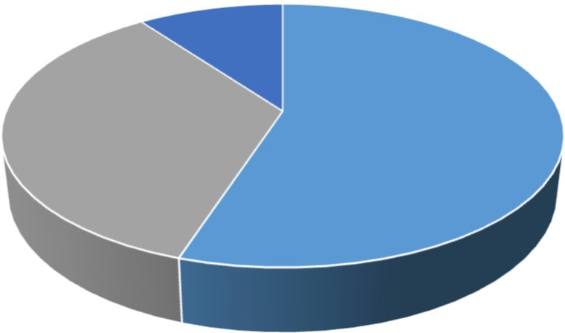

10

35

55

|  |  |  |  |
| --- | --- | --- | --- |
| INDICES | SAMPLE  SIZE | PERCENTAGE% | C.F |
| V2 | 55 | 55% | - |
| BAAZAR  KOLKATA | 35 | 35% | 90 |
| OTHERS | 10 | 10% | 100 |

V2 BAAZAR KOLKATA OTHERS

CONSUMER PERCEPTION ON KNOWING V2 AND

BAAZAR KOLKATA

INTERPRETATION

There are majority of people who knows V2 than baazar Kolkata and only few people knows about Other store.

* 2.WHICH STORE V2 OR BAAZAR KOLKATA IS HAVING A WIDE SELECTION?

|  |  |  |  |
| --- | --- | --- | --- |
| INDICES | SAMPLE  SIZE | PERCENTAGE% | C.F |
| V2 | 50 | 50% | - |
| BAAZAR  KOLKATA | 45 | 45% | 95 |
| OTHERS | 5 | 5% | 100 |

V2 BAAZAR KOLKATA OTHERS

CONSUMER PERCEPTION ON WIDE SELECTION

INTERPRETATION

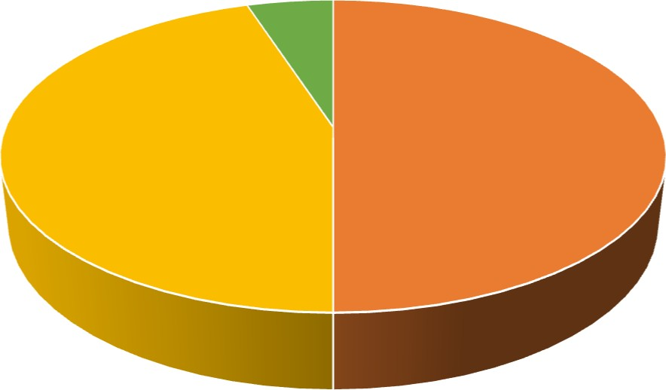

5

50

45

* There are more preference given to V2 store for the wide selection of clothes and varieties of clothes . As baazar Kolkata in not given much preference in wider selection.

## 3. WHICH STORE IS HAVING A BEST QUALITY OF PRODUCT V2 OR BAAZAR KOLKATA ?

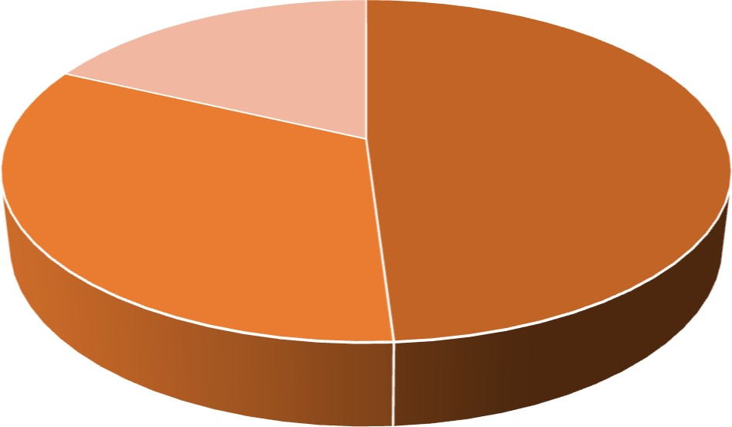

18

49

33

|  |  |  |  |
| --- | --- | --- | --- |
| INDICES | SAMPLE  SIZE | PERCENTAGE% | C.F |
| V2 | 49 | 49% |  |
| BAAZAR  KOLKATA | 33 | 33% | 82 |
| OTHERS | 18 | 18% | 100 |

V2 BAAZAR KOLKATA OTHERS

CONSUMER PERCEPTION ON BEST QUALITY OF

PRODUCT

INTERPRETATION

There are more preference given to v2 than bazzar Kolkata for best quality of product.

#### 4. WHOSE BEHAVIOUR V2 OR BAAZAR KOLKATA IS MORE RESPONDENT TOWARDS THE CONSUMER ?

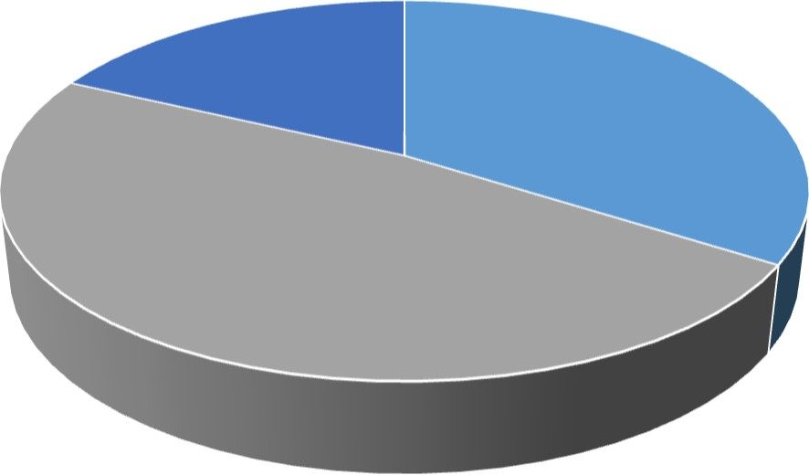

18

34

48

|  |  |  |  |
| --- | --- | --- | --- |
| INDICES | SAMPLE SIZE | PERCENTAGE% | C.F |
| V2 | 34 | 34% | - |
| BAAZAR  KOLKATA | 48 | 48% | 82 |
| OTHERS | 18 | 18% | 100 |

V2 BAAZAR KOLKATA OTHERS

CONSUMER PERCEPTION ON RESPONDENT TOWARDS

CONSUMER

INTERPRETATION

There are more preference given to the customer by the salesman in baazar Kolkata Compare to V2.

* 5. WHICH STORE GIVES MORE YEARLY DISCOUNT/OFFER V2 OR BAAZAR KOLKATA?

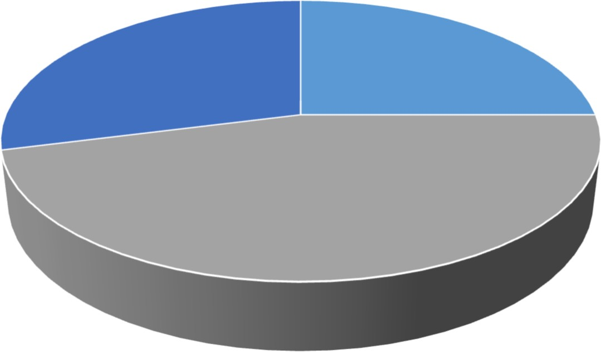

29

25

46

|  |  |  |  |
| --- | --- | --- | --- |
| INDICES | SAMPLE  SIZE | PERCENTAGE% | C.F |
| V2 | 25 | 25% | - |
| BAAZAR  KOLKATA | 46 | 46% | 71 |
| OTHERS | 29 | 29% | 100 |

V2 BAAZAR KOLKATA OTHERS

CONSUMER PERCEPTION ON MORE YEARLY DISCOUNT

INTERPRETATION

Baazar kolkata gives more yearly discount and offers to the customer compare

To V2 and other stores.

* 6. WHOSE FRANCHISE IS MORE V2 OR BAAZAR KOLKATA ?

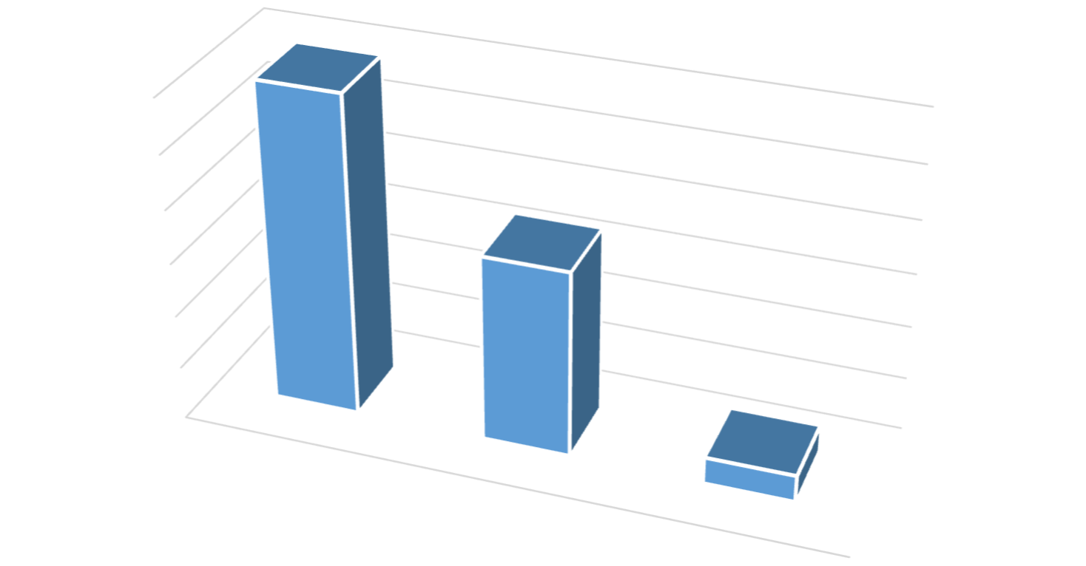

|  |  |  |  |
| --- | --- | --- | --- |
| INDICES | SAMPLE  SIZE | PERCENTAGE% | C.F |
| V2 | 60 | 60% | - |
| BAAZAR  KOLKATA | 35 | 35% | 95 |
| OTHERS | 5 | 5% | 100 |

SAMPLE SIZE

OTHERS

BAAZAR KOLKATA

V2

5

30

20

10

0

35

60

50

40

60

CONSUMER PERCEPTION ON FRANCHISE

INTERPRETATION

V2 has more franchise compare to baazar Kolkata and other shopping stores.

* 7. WHICH STORE IS HAVING MORE NO. OF SALESMAN FOR THE SERVICE OF THE CUSTOMERS ?

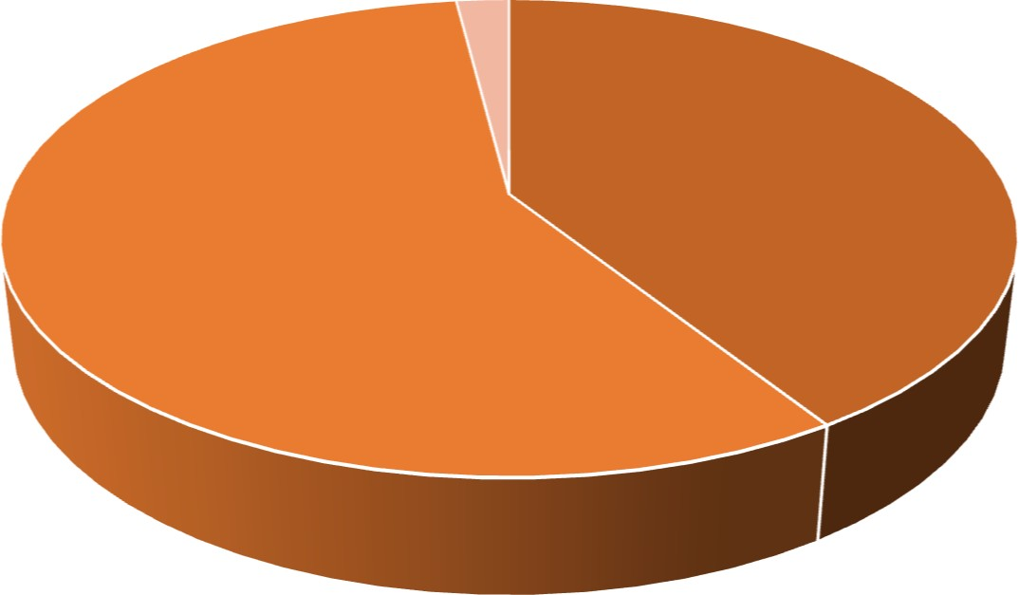

2

41

57

|  |  |  |  |
| --- | --- | --- | --- |
| INDICES | SAMPLE  SIZE | PERCENTAGE% | C.F |
| V2 | 41 | 41% | - |
| BAAZAR  KOLKATA | 57 | 57% | 98 |
| OTHERS | 2 | 2% | 100 |

V2 BAAZAR KOLKATA OTHERS

CONSUMER PERCEPTION ON SALESMAN FOR SERVICE

INTERPRETATION

There are more salesman present in baazar Kolkata than v2 and other stores for

The service of customers.

* 8. WHICH STORE IS MORE SPACIOUS V2 OR BAAZAR KOLKATA?

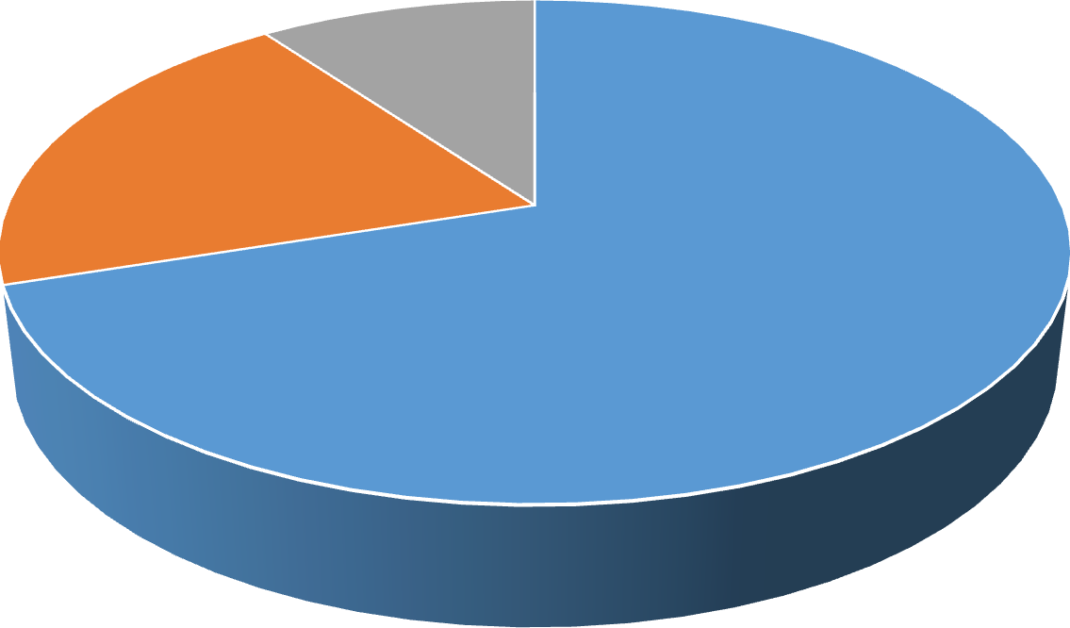

10

20

70

|  |  |  |  |
| --- | --- | --- | --- |
| INDICES | SAMPLE  SIZE | PERCENTAGE% | C.F |
| V2 | 70 | 70% | - |
| BAAZAR  KOLKATA | 20 | 20% | 90 |
| OTHERS | 10 | 10% | 100 |

V2 BAAZAR KOLKATA OTHERS

CONSUMER PERCEPTION ON AREA OF STORE

INTERPRETATION

V2 has more space and coverage area compare to baazar Kolkata and other stores.

* 9.WHICH STORE V2 OR BAAZAR KOLKATA ADVERTISEMENT IS MORE POPULAR AMONG THE CONSUMERS ?

|  |  |  |  |
| --- | --- | --- | --- |
| INDICES | SAMPLE SIZE | PERCENTAGE% | C.F |
| V2 | 63 | 63% |  |
| BAAZAR KOLKATA | 31 | 31% | 94 |
| OTHERS | 6 | 6% | 100 |

SAMPLE SIZE

70

60

50

40

30

20

10

0

63

V2

BAAZAR KOLKATA

OTHERS

CONSUMER PERCEPTION ON ADVERTISEMENT OF STORE

INTERPRETATION

6

31

* Advertisement of v2 is more popular among the consumer rather than baazar Kolkata and other stores.
* 10. WHICH STORE V2 OR BAAZAR KOLKATA KEEP MORE NO. OF BRAND IN THE STORE?

|  |  |  |  |
| --- | --- | --- | --- |
| INDICES | SAMPLE  SIZE | PERCENTAGE% | C.F |
| V2 | 50 | 50% | - |
| BAAZAR  KOLKATA | 45 | 45% | 95 |
| OTHERS | 5 | 5% | 100 |

SAMPLE SIZE

OTHERS

BAAZAR KOLKATA

V2

0

10

20

30

40

50

60

CONSUMER PERCEPTION ON MORE N0. OF BRAND

INTERPRETATION

50

45

5

There are more no. of brands in v2 as compare to baazar Kolkata and other stores.

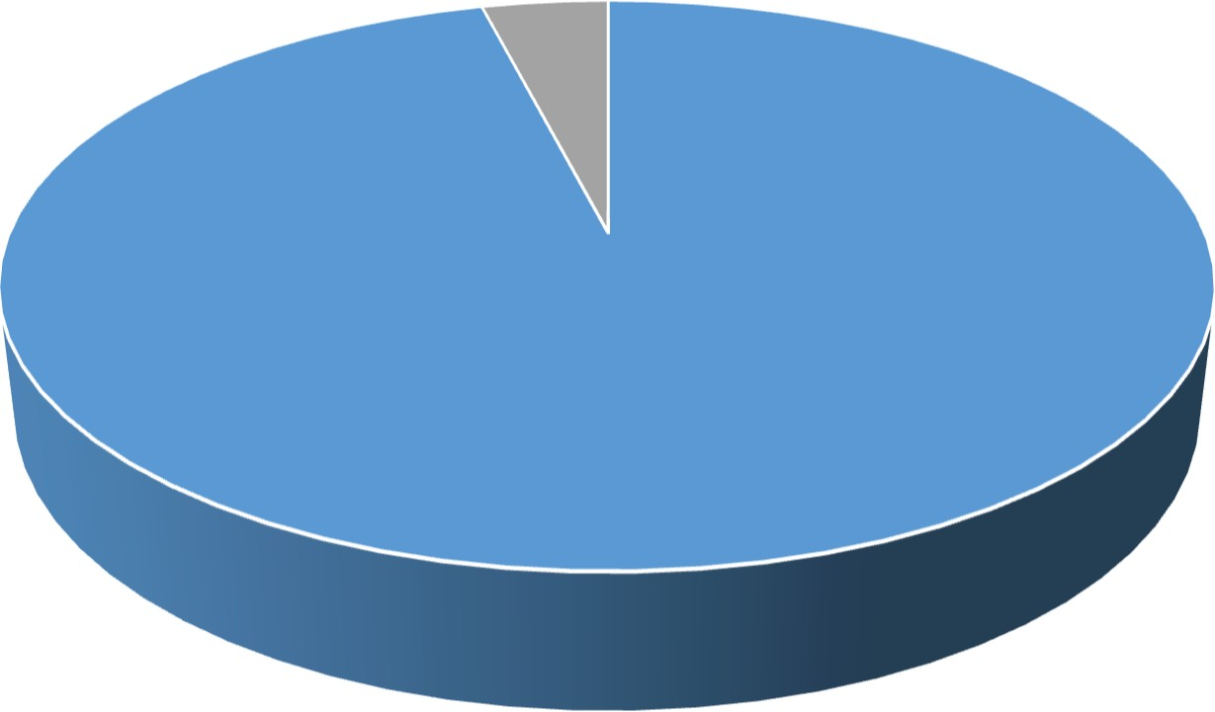

4

96

* 11. WHICH STORE V2 OR BAAZAR KOLKATA PROVIDE ONLINE SHOPPING TO THE CONSUMER?

|  |  |  |  |
| --- | --- | --- | --- |
| INDICES | SAMPLE  SIZE | PERCENTAGE% | C.F |
| V2 | 96 | 96% | - |
| BAAZAR  KOLKATA | 0 | 0% | 96 |
| OTHERS | 4 | 4% | 100 |

V2 BAAZAR KOLKATA OTHERS

CONSUMER PERCEPTION ON ONLINE SHOPPING

0

INTERPRETATION

Only v2 provide the online shopping for the consumers . Baazar Kolkata doesn’t provide any online shopping app for the consumers.

* 12. WHICH STORE V2 OR BAAZAR KOLKATA PROVIDE AFFORDABLE PRICE TO THE CONSUMER?

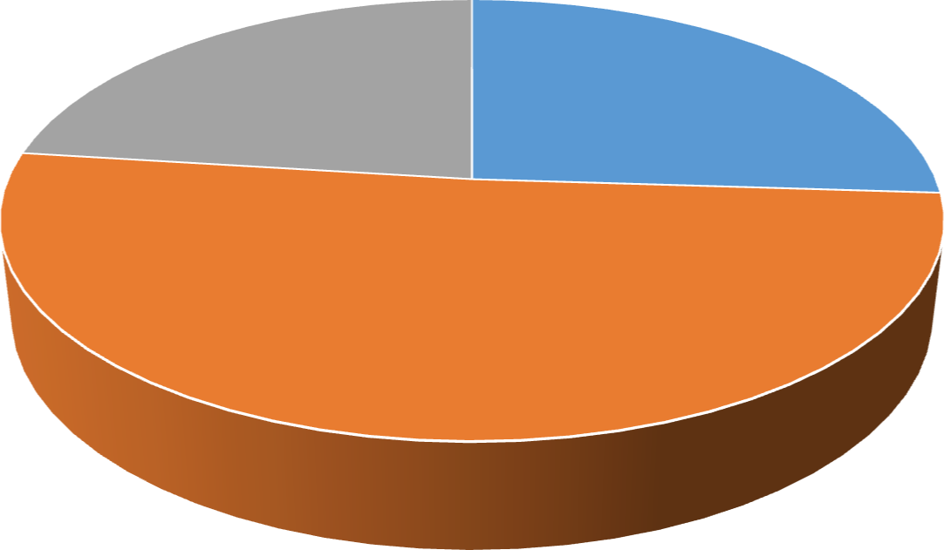

23

26

51

|  |  |  |  |
| --- | --- | --- | --- |
| INDICES | SAMPLE SIZE | PERCENTAGE% | C.F |
| V2 | 26 | 26% | - |
| BAAZAR KOLKATA | 51 | 51% | 77 |
| OTHERS | 23 | 23% | 100 |

V2 BAAZAR KOLKATA OTHERS

CONSUMER PERCEPTION ON AFFORDABLE PRICE

INTERPRETATION

Bazzar Kolkata provide affordable price to the consumer as v2 and other stores is bit expensive . As consumer prefer to shop in baazar Kolkata.

* 13. WHICH STORE V2 OR BAAZAR KOLKATA FOLLOWS THE PROTOCOL AND SAFETY TOWARDS THE CONSUMER DURING COVID 19?

|  |  |  |  |
| --- | --- | --- | --- |
| INDICES | SAMPLE  SIZE | PERCENTAGE% | C.F |
| V2 | 34 | 34% | - |
| BAAZAR KOLKATA | 33 | 33% | 67 |
| OTHERS | 33 | 33% | 100 |

33

33

34

INTERPRETATION

0% 10% 20% 30% 40% 50% 60% 70% 80% 90% 100%

SAMPLE SIZE

V2

BAAZAR KOLKATA

OTHERS

CONSUMER PERCEPTION ON SAFETY TOWARDS THE

CONSUMER

Every stores v2 , baazar Kolkata others provide same level of safety towards the consumer during covid-19.

* 14. WHICH STORE V2 OR BAAZAR KOLKATA PROVIDE EASY RETURN POLICY?

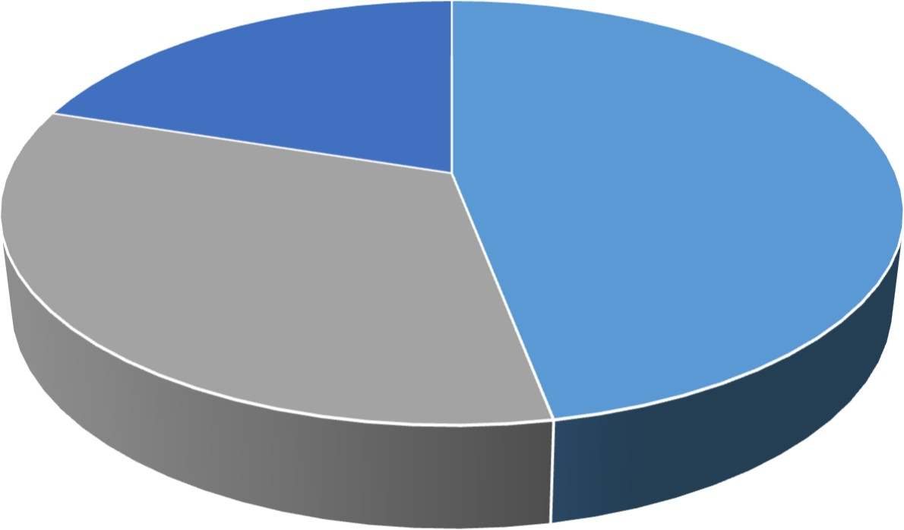

20

47

33

|  |  |  |  |
| --- | --- | --- | --- |
| INDICES | SAMPLE  SIZE | PERCENTAGE% | C.F |
| V2 | 47 | 47% | - |
| BAAZAR  KOLKATA | 33 | 33% | 80 |
| OTHERS | 20 | 20% | 100 |

V2 BAAZAR KOLKATA OTHERS

CONSUMER PERCEPTION ON EASY RETURN POLICY

INTERPRETATION

V2 Is having a fast and easy return policy as compare to baazar Kolkata and other stores. AS v2 respond to the consumer very fast.

* 15. WHICH STORE V2 OR BAAZAR KOLKATA HAVE MORE NO. OF CONSUMER FEEDBACK ?

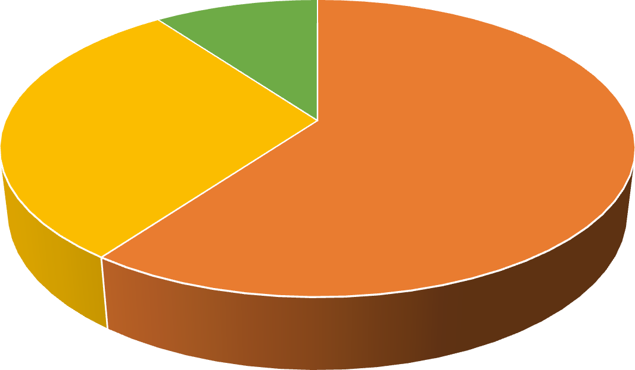

10

30

60

|  |  |  |  |
| --- | --- | --- | --- |
| INDICES | SAMPLE SIZE | PERCENTAGE% | C.F |
| V2 | 60 | 60% | - |
| BAAZAR  KOLKATA | 30 | 30% | 90 |
| OTHERS | 10 | 10% | 100 |

V2 BAAZAR KOLKATA OTHERS

CONSUMER PERCEPTION ON FEEDBACK

INTERPRETATION

There are more no. of consumer given the feedback towards v2 than baazar Kolkata and other stores.

SUGGESTIONS AND RECOMMENDATION

* Baazar Kolkata should improve the service.
* Baazar Kolkata should increase their human strength at store. Most of the time sales person was busy with the stock or material handling procedures, so for them it is getting tougher to attend all the customers.
* Few of the customers cannot find what they want. So Baazar Kolkata should focus on these problems for better satisfaction of customer and to expand the variety.
* Baazar kolkata should maintain the stock/products of new trends.
* In v2 music system should be mild.
* In v2 For some products price should be low.
* V2 should go for the grocery items.
* In V2 Sales person need training, like grooming, talking.

CONCLUSION

V2 and baazar Kolkata is a major shopping store for today’s customer. It is a place where customers find variety of products at a reasonable price. It has positioned itself in the market as a discounted store. Both the stores holds a huge customer base. The majority of customers belong to middle class family. The young generation also likes shopping and moving around in v2 and baazar Kolkata.

People not only visit v2 and big baazar to do shopping but also visit for outing purpose as it provides a very nice ambience to its customers. As people go to shopping stores they just tend to move around wheather it is for shopping purpose or outing purpose. The major drawback of v2 and baazar Kolkata is that it lacks in providing enough parking space for its customers. This may discourage the customers to come to v2 or baazar Kolkata and shop as they face difficulty in parking their vehicles.

BIBLIOGRAPHY

* + BOOKS –
    - PHILIP KOTLER “Marketing Management”
    - C.R. KOTHARI

“ Research Methodology”

* + WEBSITES _
    - [www.baazarkolkata.com](http://www.baazarkolkata.com/)
    - [www.v2retail.com](http://www.v2retail.com/)
  + REFERENCE _
    - Survey is done for v2 and baazar Kolkata .

ANNEXURE

Name……………………

Phone/contact:…………

Date……………………

Mail ID………………….

* + 1. HOW MANY PEOPLE KNOWS V2 AND BAAZAR KOLKATA ?

(a) V2 [ ] (b) baazar Kolkata [ ] (c) others [ ]

* + 2.WHICH STORE V2 OR BAAZAR KOLKATA IS HAVING A WIDE SELECTION?

(a) V2 [ ] (b) baazar Kolkata [ ] (c) others [ ]

* + 3.WHICH STORE IS HAVING A BEST QUALITY OF PRODUCT V2 OR BAAZAR KOLKATA ?

(a) V2 [ ] (b) baazar Kolkata [ ] (c) others [ ]

* + 4. WHOSE BEHAVIOUR V2 OR BAAZAR KOLKATA IS MORE RESPONDENT TOWARDS THE CONSUMER ?

(a) V2 [ ] (b) baazar Kolkata [ ] (c) others [ ]

* + 5. WHICH STORE GIVES MORE YEARLY DISCOUNT/OFFER V2 OR BAAZAR KOLKATA?

1. V2 [ ] (b) baazar Kolkata [ ] (c) offers [ ]
   * 6. WHOSE FRANCHISE IS MORE V2 OR BAAZAR KOLKATA?
   1. V2 [ ] (b) baazar Kolkata [ ] (c) others [ ]
   * 7. WHICH STORE IS HAVING MORE NO. OF SALESMAN FOR THE SERVICE OF THE CUSTOMERS ?

(a) V2 [ ] (b) baazar Kolkata [ ] (c) others [ ]

* + 8. WHICH STORE IS MORE SPACIOUS V2 OR BAAZAR KOLKATA?

(a) V2 [ ] (b) baazar Kolkata [ ] (c) others [ ]

* + 9.WHICH STORE V2 OR BAAZAR KOLKATA ADVERTISEMENT IS MORE POPULAR AMONG THE CONSUMERS ?

(a) V2 [ ] (b) baazar kolkata [ ] (c) others [ ]

* + 10. WHICH STORE V2 OR BAAZAR KOLKATA KEEP MORE NO. OF BRAND IN THE STORE?

(a) V2 [ ] (b) baazar kolkata [ ] (c) others [ ]

* + 11. WHICH STORE V2 OR BAAZAR KOLKATA PROVIDE ONLINE SHOPPING TO THE CONSUMER?

(a) V2 [ ] (b) baazar Kolkata [ ] (c) others [ ]

* + 12. WHICH STORE V2 OR BAAZAR KOLKATA PROVIDE AFFORDABLE PRICE TO THE CONSUMER?

(a) V2 [ ] (b) baazar Kolkata [ ] (c) others [ ]

* + 13. WHICH STORE V2 OR BAAZAR KOLKATA FOLLOWS THE PROTOCOL AND SAFETY TOWARDS THE CONSUMER DURING COVID 19?

(a) V2 [ ] (b) baazar Kolkata [ ] (c) others [ ]

* + 14. WHICH STORE V2 OR BAAZAR KOLKATA PROVIDE EASY RETURN POLICY?

(a) V2 [ ] (b) baazar Kolkata [ ] (c) others [ ]

* + 15. WHICH STORE V2 OR BAAZAR KOLKATA HAVE MORE NO. OF CONSUMER FEEDBACK ?

(a) V2 [ ] (b) baazar Kolkata [ ] (c) others [ ]